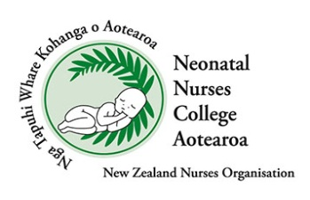

Neonatal Nurses College Aotearoa (NNCA)
Professional Development Grant
NNCA has up to $10,000 available each year to support Professional Development Grants. The maximum scholarship is $1,000 per person at the discretion of the NNCA Executive Committee, and applications are considered at the quarterly national executive meetings.
Purpose of the Grant
To assist resident New Zealand Neonatal Nurses in professional development benefiting the care provision for neonates and their whanau.
Criteria for Grant application
- The applicant must currently be a full financial member of NZNO, and have been a full member of NNCA for at least 12 months.
- Applications must be made with the official application form.
- The grant may be used towards post-graduate study, courses, seminars and conferences, or research projects relating to neonatal nursing. Information of the conference, seminar or course should be included with your application.
- Priority is given to nurses starting research and/ or writing for a peer-reviewed journal.
- Presentation of how the grant was used must be completed by all recipients. This may be presented verbally at the NNCA symposium, or as a written piece for Kaitiaki, or the NNCA social media accounts. If the grant is being used for research, please email a copy of the research to neonatalcollege@nzno.org.nz once completed.
- Written presentations must be submitted within six weeks of attending or completing the activity for which the grant was used.
- The successful applicant should use the funding within the allocated financial year.
- Applicants will be notified in writing by the NNCA Executive Committee if the grant has been awarded, or not. Please email us if you have submitted an application and have not heard the outcome 1 week post our quarterly meetings.
- Committee quarterly meeting dates for 2026 are:
  - 6th May 2026
  - 13th August 2026
  - 19th November 2026

Application Requirements
- Applicants must have signed endorsement from their manager.
- All sections of the below application form completed electronically.
- A report that summarises your contribution to neonatal care at a local or national level (less than 250 words)
- A summary of the proposed scholarship, how it will enhance your neonatal career, and how you will share the information you gained.

Selection process
The Selection Panel consists of the NNCA Executive Committee, and nominees are scored by the following criteria

Criterion | Weighting
Quality of application | 10%
Report summary outlining contribution to neonatal care | 45%
Local and/or national feedback | 25%
Summary of professional benefit of scholarship | 20%

Please send completed applications to: neonatalcollege@nzno.org.nz

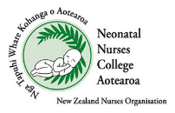
Neonatal Nurses College Aotearoa (NNCA)
Professional Development Grant Application Form

Name of Applicant
Email address
Postal Address
Home phone contact
Work phone contact
Workplace
Job Title
NZNO number
Funding to go towards (i.e., conference/ travel / Post Grad paper/ Thesis)
Amount applying for
Please describe how you will share the information learned

Please outline all assistance (if any) you will receive from your employer

If the activity is not undertaken, do you agree to return any money received from the NNCA? Yes / No
Endorsement by manager/ senior colleague is attached
Signed:
Date:
Applicant:
Signed:
Date:

Please attach:
  - A scanned copy of the conference/ seminar or proposed course information.
  - A report summarizing your contribution to neonatal care (less than 250 words), and
  - A summary of the proposed scholarship and how it will enhance your neonatal career.

Please email completed applications to: neonatalcollege@nzno.org.nz

NZNO use only
Date received by NZNO
Outcome/ approval by Selection Panel
Date
Nominee notification date
Amount awarded
NZNO Finance - date paid
NZNO Admin - date entered into Mems database

